**Assignment 2: Network Analysis in ArcGIS**

**By: Grisham Nathan**

**Student No: 1001314927**

**Part 1**

**Question 5**

Total travel distance in miles is 2280 miles

**Question 6**

It will take approximately 35 hours to drive from Helena to Charlotte using the interstates.

**Question 8**

It will take the ambulance 3 minutes to travel from the closest fire station (Location 2) to the incident which is 1.5 miles in distance from each other.

**Question 9**

The size of the 2-minute area of location 1 is 2562372.717378 meters in area.

**Question 10**

The size of the 2-minute service area of location 2 is 1882563.751322 meters in area.

**Part 2**

**b)**

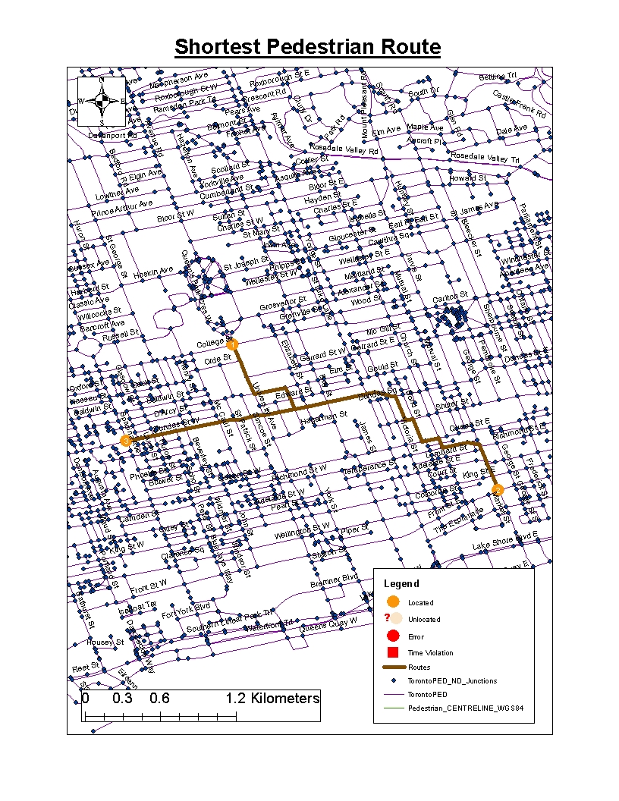The total travel distance is 5.4 kilometers.

**c)**

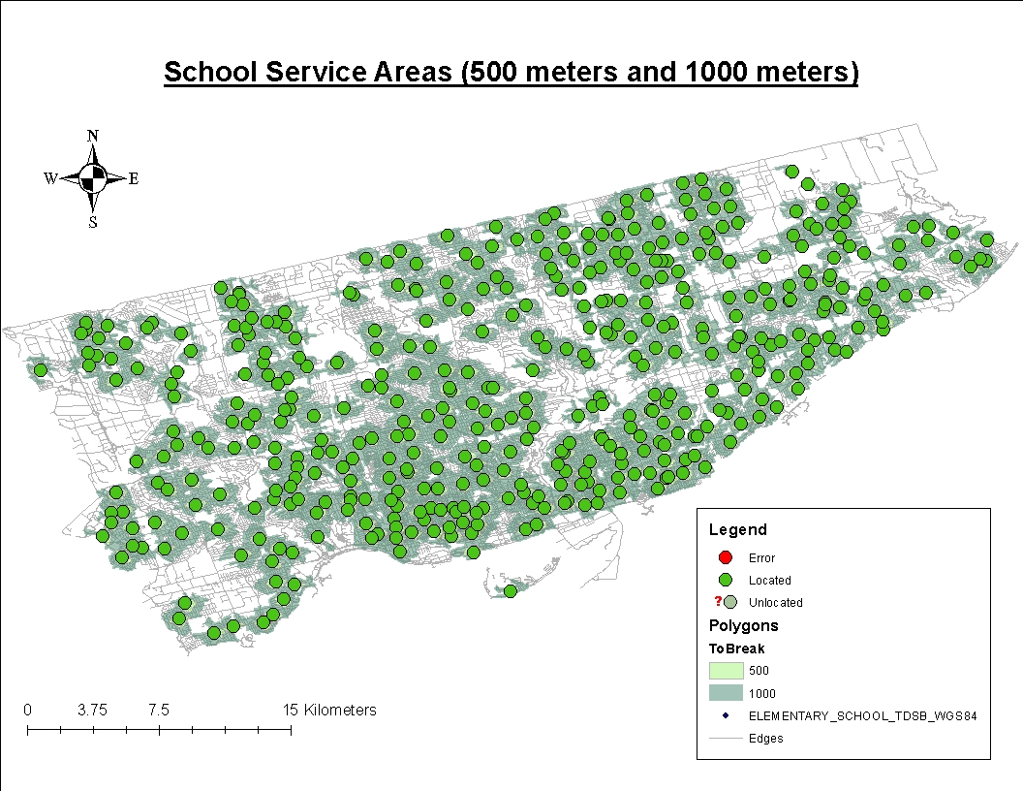

Elementary school coverage is relatively widespread and prominent throughout the City of Toronto. The areas that do not have good walking coverage to schools are the ones that are primarily used for commercial and industrial land uses throughout Toronto. Examples of this being seen are the industrial areas in the Northwest end of Toronto/Etobicoke and the Northeast end of Toronto/Scarborough. Forests, such as the Don Parklands, golf courses and parks also do not have good walking coverage to schools. I see some residential areas in the east end of Scarborough/Toronto and also some residential areas in Etobicoke that do not have good walking coverage to schools.

**d)**

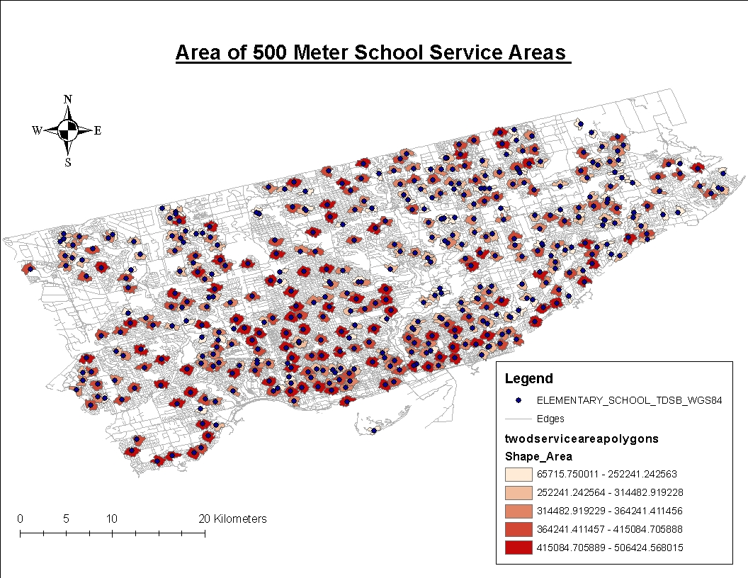

Most of the large 500m Service Areas are clustered in Midtown and Downtown Toronto (Below St. Clair Avenue).However there are many occurrences of large 500m Service Areas in Etobicoke and North York. Many small 500mService Areas are also clustered in Downtown Toronto and the Southern end of East York. There is heavy clustering of small 500mService Areas in the north end and east end of Scarborough. Small 500mService Areas tend to be more dispersed than large 500m Service Areas. It seems that the schools that are in heavily dense urbanized grid street networks tend to have large 500m Service Areas and schools with a less dense residential neighbourhood street network tend to have small 500m Service Areas. This is makes sense because there is less mobility in less dense residential neighbourhood street networks compared to urbanized grid street networks which tend to have high mobility. As a result, schools in the residential neighbourhoods will be less accessible than the schools in the heavily urbanized areas of Toronto.